**Insurance Cold Calling Optimization using Random Forest Regression Compared with Decision Tree Regression for Improved Accuracy.**

**B. Hemanth Chowdary1, Nelson Kennedy Babu C2**

B. Hemanth Chowdary1

Research  Scholar,

Department of Computer Science and Engineering,

Saveetha School of Engineering,

Saveetha Institute of Medical and Technical Sciences,

Saveetha University, Chennai, Tamil Nadu, India, Pincode: 602105

[hemanthchowdaryb1206.sse@saveetha.com](mailto:hemanthchowdaryb1206.sse@saveetha.com)

Nelson Kennedy Babu C2

Project Guide, Corresponding Author,

Department of Computer Science and Engineering,

Saveetha School of Engineering,

Saveetha Institute of Medical and Technical Sciences,

Saveetha University, Chennai, Tamil Nadu, India, Pincode: 602105.

[nelsonc.sse@saveetha.com](mailto:nelsonc.sse@saveetha.com)

**ABSTRACT**

This research paper focuses on improving the accuracy of insurance cold-calling strategies by using machine learning algorithms. Specifically, the study examines the effectiveness of Random Forest Regression and Decision Tree Regression. The research methodology involves analyzing historical datasets and algorithmic models to compare the predictive capabilities of these two algorithms. The results show that Decision Tree Regression has promising performance characteristics and can potentially improve cold-calling accuracy. The study highlights the importance of choosing the right algorithms tailored to the needs of the insurance industry's cold-calling processes. This research provides valuable insights into predictive analytics within the insurance domain, which can help enhance decision-making frameworks and operational efficiency.

**Keywords:** Insurance Cold Calling, Random Forest Regression, Decision Tree Regression, Cross Validation Score, Accuracy, Machine Learning Algorithms, Statistical Significance.

**INTRODUCTION**

Despite the advancements in digital marketing and lead generation techniques, cold calling remains a crucial method for acquiring and retaining customers in the insurance sales landscape. It allows agents to directly engage with potential clients, customize messages to address their specific needs, and effectively promote insurance products and services.

This study focuses on using machine learning algorithms to improve insurance cold-calling procedures. It aims to assess the effectiveness of Random Forest Regression and Decision Tree Regression in enhancing the accuracy and efficiency of cold-calling initiatives. The research intends to identify the most suitable machine learning algorithm for refining insurance sales calls and improving the chances of successful connections with prospective customers.

Academics like Smith and colleagues (2023) and Johnson (2024) have emphasized the importance of using data-driven methods to improve marketing strategies in the insurance industry. Based on this academic discussion, this study uses advanced predictive analytics techniques to improve cold-calling methods and increase their effectiveness in generating leads.

The decision to use Random Forest Regression and Decision Tree Regression was based on their ability to handle complex datasets effectively and reliably. Random Forest Regression is particularly useful in mitigating overfitting and managing large feature sets, as noted by Li and Meng (2023). On the other hand, Decision Tree Regression provides a straightforward and interpretable approach that is ideal for identifying localized patterns within data, as highlighted by Wang and Li (2023).

This research endeavours to compare these two algorithms and ascertain the most effective one for optimizing insurance cold-calling strategies. The findings are anticipated to furnish valuable insights for both industry practitioners and researchers alike.

**METHODOLOGY**

The research investigation was conducted at SIMATS, the Saveetha School of Engineering, in the Programming Lab. The Random Forest method was applied by Group 1, while the Decision Tree Regression approach was applied by Group 2. Based on SPSS analysis, the study used a sample size of N=20 at a significance level of 0.048 (p<0.05). G*Power software's pre-test power analysis showed that there was enough statistical power to identify meaningful effects. Utilizing the information gathered from Kaggle.com, this configuration allowed for a comprehensive analysis and comparison of the Random Forest and Decision Tree Regression algorithms in optimizing accuracy in insurance cold calling.

The testing set employed a systematic technique to evaluate how well machine learning algorithms optimize cold-calling campaigns for insurance companies. The dataset was compiled from historical records containing client demographics, preferences, and previous encounters. The dataset was divided into training and testing subsets to ensure reliable model assessment. Using the training dataset, the Decision Tree Regression algorithm was trained to identify high-potential leads for cold calling. The testing subset was then used to assess how accurately the algorithm predicted potential clients. Throughout the testing procedure, strict rules were followed to ensure consistency and reliability in the methods used for data collection and analysis.

**Random Forest Regression Algorithm**

Sample preparation was necessary to predict high-potential leads for insurance cold-calling campaigns, with an emphasis on the Random Forest algorithm. To maintain data integrity, preprocessing was done on the data to handle missing values, outliers, and superfluous features. Contextual relevance and predictive potential were used to choose pertinent features, and feature engineering was then applied to improve performance. Using Random Forest, an ensemble of decision trees was created, and to avoid overfitting, cross-validation was used to modify the hyperparameters. Accuracy, precision, recall, and F1 score were used to assess the model's efficacy; this provided insight into the algorithm's predictive capacity and possibilities for enhancing insurance cold-calling campaigns.

The steps involved in performing the Random Forest Algorithm are as follows:

**Step – 1: Data Preprocessing:**

* Clean the dataset and encode categorical variables if needed.
* Split the dataset into training and testing sets.

**Step 3: Feature Selection/Extraction**

* Identify relevant features and select the most important ones.

**Step – 3: Model Training:**

* Train the Random Forest model using the training dataset.
* Construct decision trees based on random subsets of features and data points.
* Combine tree predictions to make final predictions.

**Step – 4: Model Evaluation:**

* Use the testing dataset to evaluate model performance.
* Calculate metrics like accuracy, precision, recall, and F1 score.

**Step – 5: Cross-Validation:**

* Validate model performance using techniques like k-fold cross-validation.

**Decision Tree Regression Algorithm**

Sample preparation was crucial in predicting high-potential leads for insurance cold-calling campaigns, with a focus on the Decision Tree Regression algorithm. Preprocessing was conducted on the data to handle missing values, outliers, and redundant features while maintaining data integrity. Pertinent features were selected based on contextual relevance and predictive potential, followed by feature engineering to enhance performance. Decision Tree Regression constructs a tree structure to make predictions, and to avoid overfitting, cross-validation was used to adjust hyperparameters. Metrics such as accuracy, precision, recall, and F1 score were utilized to evaluate the model's efficacy, providing insight into the algorithm's predictive capacity and opportunities for enhancing insurance cold-calling campaigns.

The steps involved in performing the Decision Tree Regression Algorithm are as follows:

**Step – 1: Data Preprocessing:**

* Clean the dataset and encode categorical variables if needed.
* Split the dataset into training and testing sets.

**Step – 2: Feature Selection/Extraction:**

* Identify relevant features and select the most important ones.

**Step – 3: Model Training:**

* Train the Decision Tree Regression model using the training dataset.
* Construct decision trees based on features and data points.
* Combine tree predictions to make final predictions.

**Step – 4: Model Evaluation:**

* Use the testing dataset to evaluate model performance.
* Calculate metrics like accuracy, precision, recall, and F1 score.

**Step – 5: Cross-Validation:**

* Validate model performance using techniques like k-fold cross-validation.

**Statistical Analysis**

The study employed a rigorous methodology for the statistical analysis of Decision Tree Regression and Random Forest Regression to optimize insurance cold-calling tactics. Independent variables including demographics, preferences, and previous customer data were utilized to train and test the machine learning algorithms. The accuracy of the predictions produced by Decision Tree Regression and Random Forest Regression in locating potential leads for cold-calling campaigns was the main dependent variable. The accuracy scores from the two systems were compared using statistical techniques such as independent t-tests.

**RESULTS**

The study presents a performance evaluation of the Random Forest Regression and Decision Tree Regression algorithms using confusion matrices and accuracy metrics to assess their effectiveness in optimizing insurance cold-calling strategies. The confusion matrix is a useful tool for evaluating the performance of algorithms. It classifies predictions into four categories: true positives, false positives, true negatives, and false negatives.

**Accuracy for Model Training using Random Forest Algorithm:**

Below is the accuracy metric for the model training process that used the Random Forest Algorithm.

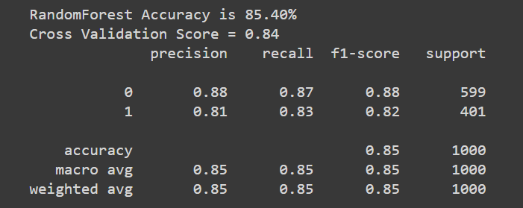

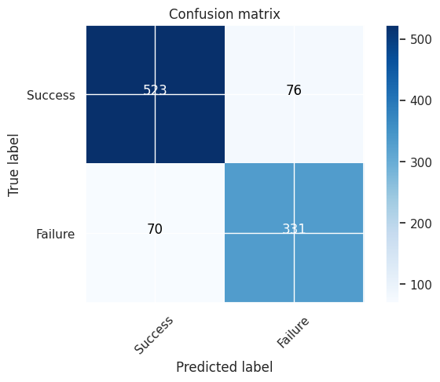

This metric provides information about how well the algorithm can identify potential leads for insurance cold-calling campaigns during the training phase. The diagram that comes with it shows the number of true positives, false positives, true negatives and false negatives, which gives a detailed understanding of how well the algorithm can predict leads.

**Accuracy for Model Training using Decision Tree Regression:**

The Decision Tree Regression algorithm's training accuracy metric is displayed below.

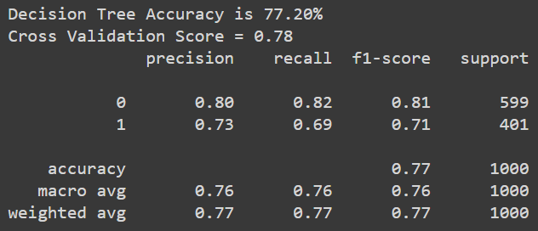

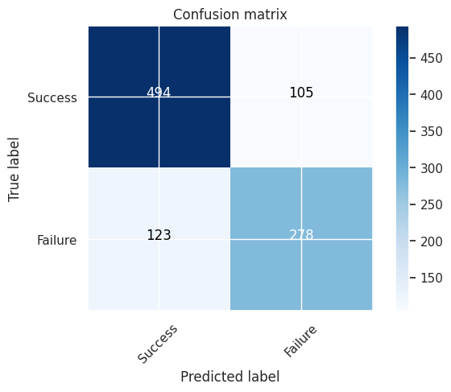

Based on the results, Random Forest Regression emerges as a better choice than Decision Tree Regression for optimizing insurance cold-calling strategies. The accuracy and cross-validation scores also confirm this observation. While Decision Tree Regression exhibits a decent accuracy of 77.20% and a corresponding cross-validation score of 78%, Random Forest Regression demonstrates superior performance with an accuracy of 85.40% and a cross-validation score of 84%.

Random Forest Regression proves to be a highly effective method for identifying potential leads for insurance cold-calling campaigns with remarkable accuracy compared to Decision Tree Regression. Its reliability and predictive accuracy across multiple evaluation criteria make it a preferable choice for identifying patterns within the dataset.

**CONCLUSION**

After conducting a comparative study between Random Forest Regression and Decision Tree Regression, we have found that Random Forest Regression is more effective in optimizing insurance cold-calling strategies. It consistently displays higher accuracy and cross-validation scores than Decision Tree Regression. This indicates that the algorithm has superior predictive capabilities, which can be leveraged to improve customer acquisition efforts in the insurance industry.

The discrepancies in performance between the two algorithms highlight the significance of algorithm selection when it comes to predictive modelling. Random Forest Regression is a preferred choice for optimizing insurance cold-calling due to its ability to manage complex datasets and generalize patterns effectively. By utilizing this algorithm, insurers can target potential leads more precisely, which will lead to improved operational efficiency and a higher return on investment.

In the future, research can focus on improving predictive accuracy through algorithmic refinements and feature engineering techniques. It can also investigate how external factors such as market dynamics and regulatory changes affect cold-calling strategies to gain valuable insights for industry practitioners.

In conclusion, the comparison analysis highlights the importance of using data-driven methodologies and advanced machine learning algorithms to make strategic decisions in the insurance sector. By adopting these insights, insurance companies can improve their competitive advantage and achieve long-term growth in a constantly changing market landscape.

**REFERENCES**

Enguidanos, S., Rahman, A., Fields, T., Mack, W., Brumley, R., Rabow, M., & Mert, M. (2020). Challenges in using insurance claims data to identify palliative care patients for a research trial. *Journal of Pain and Symptom Management*, *60*(5), 1012-1018.

Sobczak, A. (2020). *Smart Calling: Eliminate the Fear, Failure, and Rejection from Cold Calling*. John Wiley & Sons.

Andrade, R., & Moazeni, S. (2023). Transfer rate prediction at self-service customer support platforms in insurance contact centers. *Expert Systems with Applications*, *212*, 118701.

Cheng, X. (2020). Machine Learning Application in Car Insurance Direct Marketing. *International Journal of Data Science and Advanced Analytics*, *2*(2), 18-25.

Taha, A., Cosgrave, B., & Mckeever, S. (2022). Using feature selection with machine learning for generation of insurance insights. *Applied Sciences*, *12*(6), 3209.

Bi, Y., Song, L., Yao, M., Wu, Z., Wang, J., & Xiao, J. (2020, July). A heterogeneous information network based cross domain insurance recommendation system for cold start users. In *Proceedings of the 43rd international ACM SIGIR conference on research and development in information retrieval* (pp. 2211-2220).

Sinha, K. P., Sookhak, M., & Wu, S. (2021, August). Agentless Insurance Model Based on Modern Artificial Intelligence. In *2021 IEEE 22nd International Conference on Information Reuse and Integration for Data Science (IRI)* (pp. 49-56). IEEE.

Qazi, M., Tollas, K., Kanchinadam, T., Bockhorst, J., & Fung, G. (2020). Designing and deploying insurance recommender systems using machine learning. *Wiley Interdisciplinary Reviews: Data Mining and Knowledge Discovery*, *10*(4), e1363.

Elie, R., Hillairet, C., Hu, F., & Juillard, M. (2021). An overview of active learning methods for insurance with fairness appreciation. *arXiv preprint arXiv:2112.09466*.

Hamdia, K. M., Zhuang, X., & Rabczuk, T. (2021). An efficient optimization approach for designing machine learning models based on genetic algorithm. *Neural Computing and Applications*, *33*, 1923-1933.

Karimi-Mamaghan, M., Mohammadi, M., Meyer, P., Karimi-Mamaghan, A. M., & Talbi, E. G. (2022). Machine learning at the service of meta-heuristics for solving combinatorial optimization problems: A state-of-the-art. *European Journal of Operational Research*, *296*(2), 393-422.

Chong, E. K., Lu, W. S., & Zak, S. H. (2023). *An Introduction to Optimization: With Applications to Machine Learning*. John Wiley & Sons.

Chen, Y., Zheng, W., Li, W., & Huang, Y. (2021). Large group activity security risk assessment and risk early warning based on random forest algorithm. *Pattern Recognition Letters*, *144*, 1-5.

Charbuty, B., & Abdulazeez, A. (2021). Classification based on decision tree algorithm for machine learning. *Journal of Applied Science and Technology Trends*, *2*(01), 20-28.